CN LAB – WEEK 6

DIVYANSHU SHARMA

PES1UG20CS806

1. **Task** 
   1. Configuring Network:

* The network’s is organised in the required topology shown below.
* The IP Addresses for different interfaces have been assigned being used on the routers and systems.
* The routing tables are configured manually by adding the required routing information
* A PDU packet is then transferred from one system on a network to another system on a different network.
* If the packet is transfer successfully, a successful message will be shown in the bottom right corner, otherwise unsuccessful message will be shown.

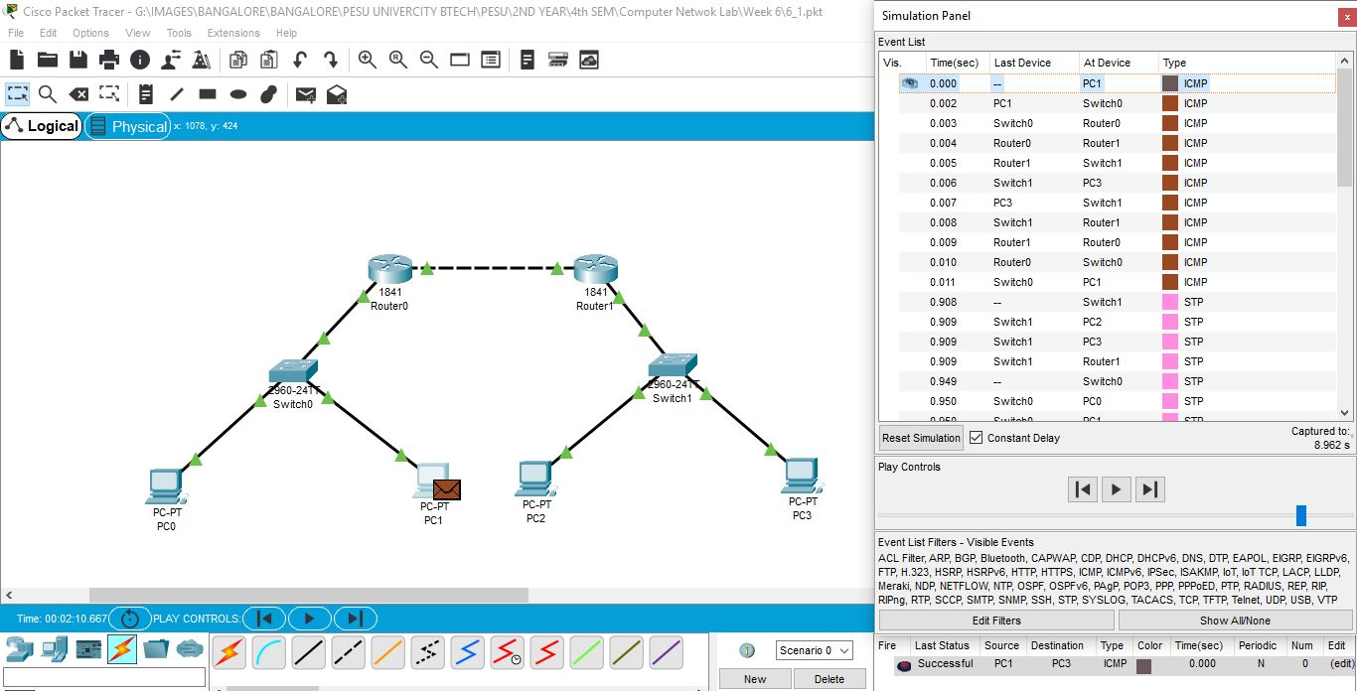

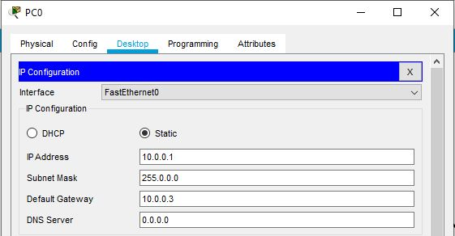

PC0

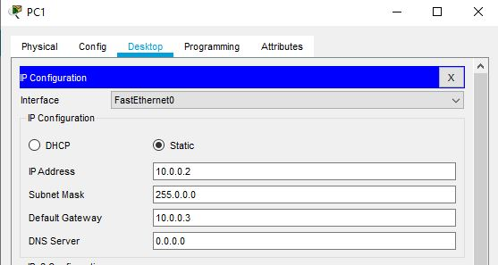

PC1

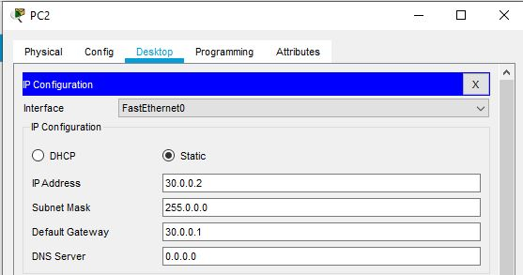

PC2

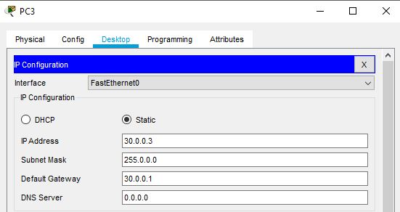

PC3

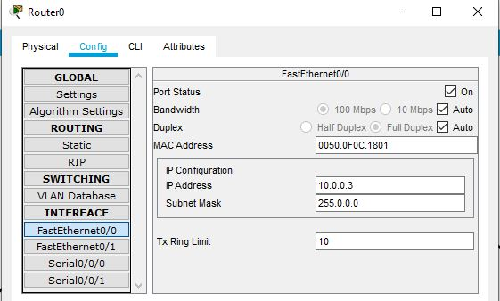

ROUTER 0 (FastEthernet0/0)

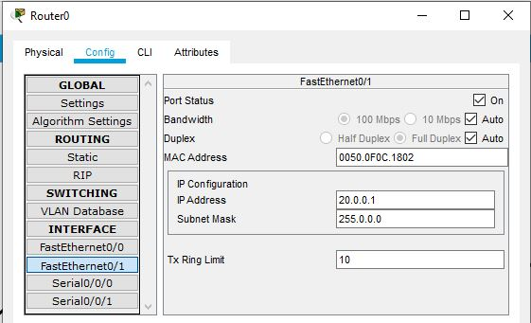

ROUTER 0 (FastEthernet0/1)

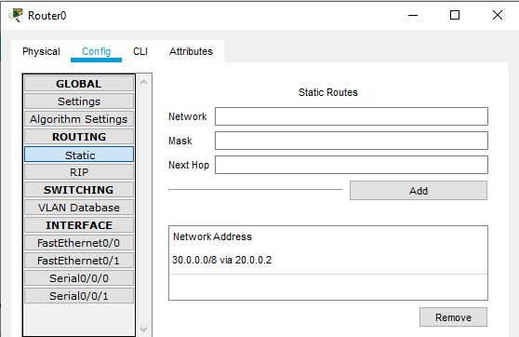

ROUTER 0 (static)

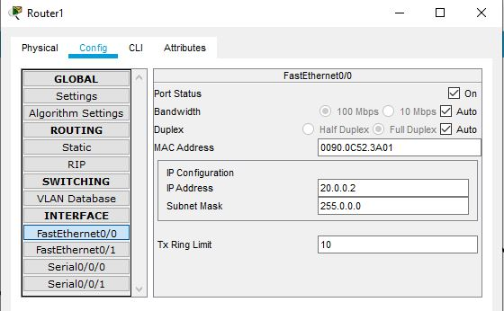

ROUTER 1 (FastEthernet0/0)

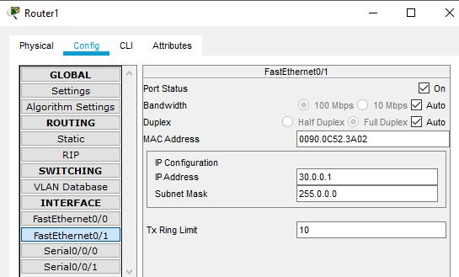

ROUTER 1 (FastEthernet0/1)

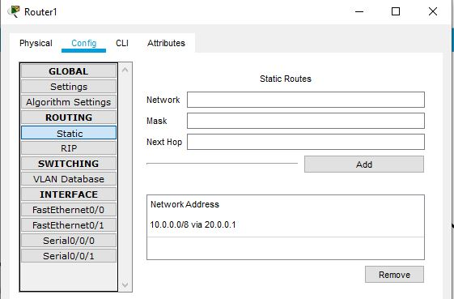

ROUTER 1 (static)

* 1. **Network and Routing Tables**

1.2.1. End Systems

|  |  |  |  |  |
| --- | --- | --- | --- | --- |
| **End System** | **Interface Name** | **IP Address** | **Subnet Mask** | **Gateway** |
| PC0 | FastEthernet0 | 10.0.0.1 | 255.0.0.0 | 10.0.0.3 |
| PC1 | FastEthernet0 | 10.0.0.2 | 255.0.0.0 | 10.0.0.3 |
| PC2 | FastEthernet0 | 30.0.0.2 | 255.0.0.0 | 30.0.0.1 |
| PC3 | FastEthernet0 | 30.0.0.3 | 255.0.0.0 | 30.0.0.1 |

1.2.2. Routers

|  |  |  |  |
| --- | --- | --- | --- |
| **Router** | **Interface Name** | **IP Address** | **Subnet Mask** |
| Router0 | FastEthernet0/0 | 10.0.0.3 | 255.0.0.0 |
| Router0 | FastEthernet0/1 | 20.0.0.1 | 255.0.0.0 |
| Router1 | FastEthernet0/0 | 20.0.0.2 | 255.0.0.0 |
| Router1 | FastEthernet0/1 | 30.0.0.1 | 255.0.0.0 |

1.2.3. Routing Tables

|  |  |  |
| --- | --- | --- |
| **Router** | **Destination Network** | **Next Hop** |
| Router0 | 30.0.0.0 | 20.0.0.2 |
| Router1 | 10.0.0.0 | 20.0.0.1 |

1. **Task 2** 
   1. Configuring Topology:

The task performed above is repeated with another topology and with different networks and the routing tables are configured accordingly.

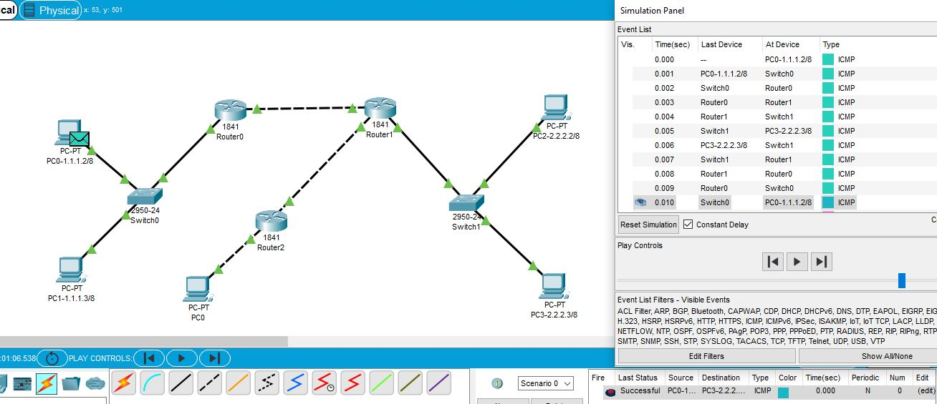

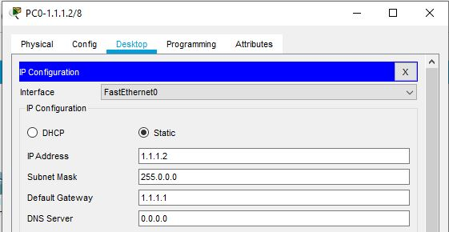

PC0 -1.1.1.2/8

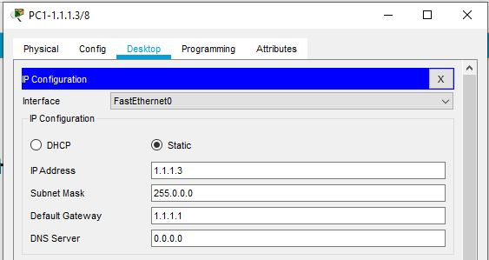

PC1 -1.1.1.3/8

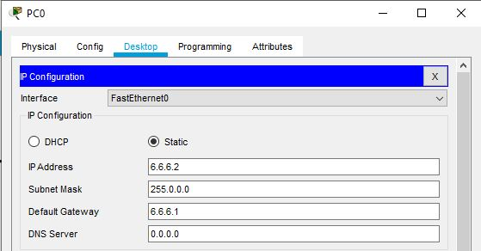

PC0

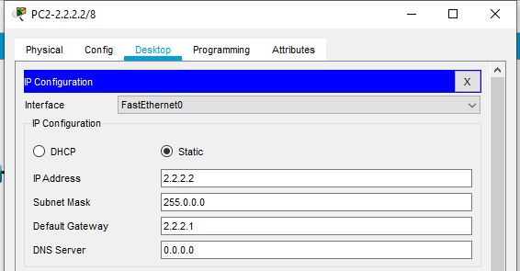

PC2 -2.2.2.2/8

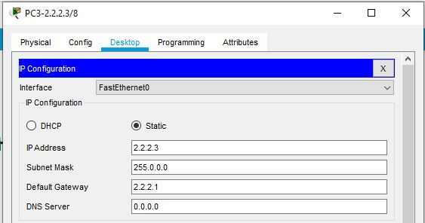

PC3 -2.2.2.3/8

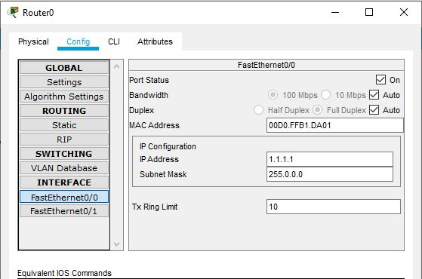

Router0 (FastEthernet0/0)

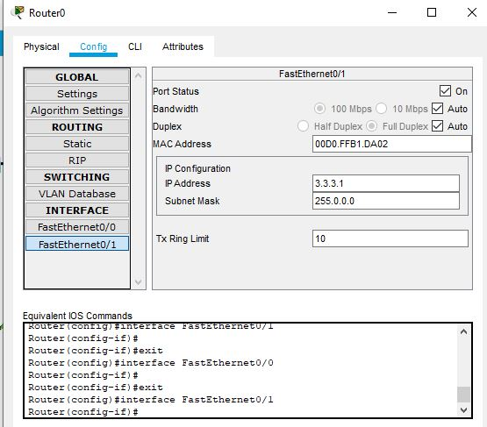

Router0 (FastEthernet0/1)

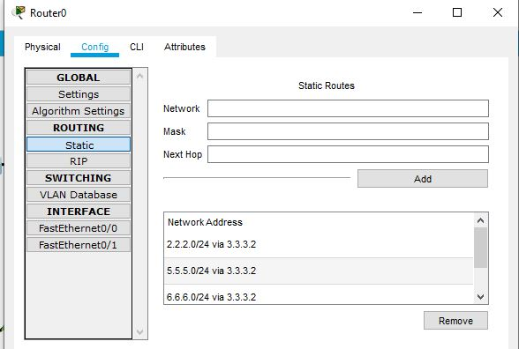

Router0 (static)

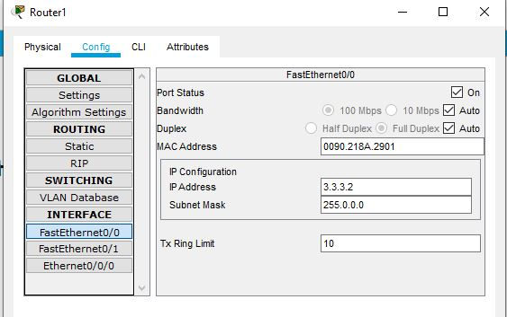

Router1 (FastEthernet0/0)

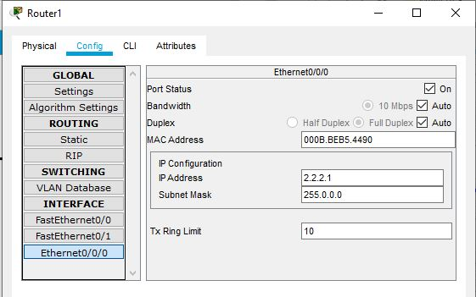

Router1 (Ethernet0/0/0)

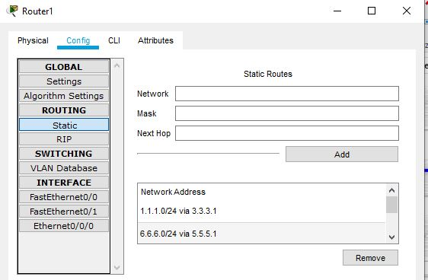

Router1 (static)

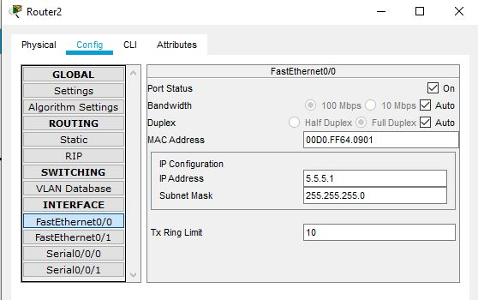

Router2 (FastEthernet0/0)

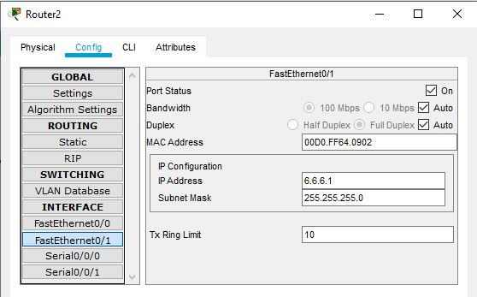

Router2 (FastEthernet0/1)

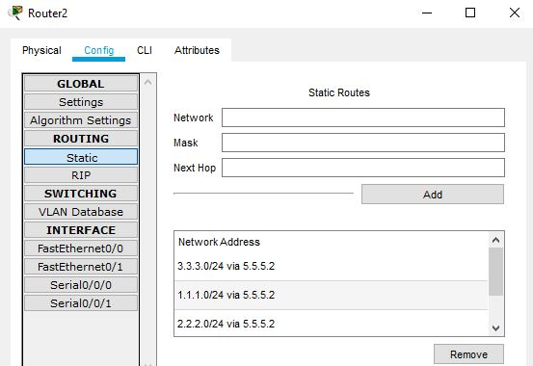

Router2 (static)

* 1. **Configuring Network and Routing Tables**
     1. **End Systems**

|  |  |  |  |  |
| --- | --- | --- | --- | --- |
| **End System** | **Interface Name** | **IP Address** | **Subnet Mask** | **Gateway** |
| PC0 -1.1.1.2/8 | FastEthernet0 | 1.1.1.2 | 255.0.0.0 | 1.1.1.1 |
| PC1 -1.1.1.3/8 | FastEthernet0 | 1.1.1.3 | 255.0.0.0 | 1.1.1.1 |
| PC0 | FastEthernet0 | 6.6.6.2 | 255.0.0.0 | 6.6.6.1 |
| PC2 -2.2.2.2/8 | FastEthernet0 | 2.2.2.2 | 255.0.0.0 | 2.2.2.1 |
| PC3 -2.2.2.3/8 | FastEthernet0 | 2.2.2.3 | 255.0.0.0 | 2.2.2.1 |

* + 1. **Routers**

|  |  |  |  |
| --- | --- | --- | --- |
| **Router** | **Interface Name** | **IP Address** | **Subnet Mask** |
| Router0 | FastEthernet0/0 | 1.1.1.1 | 255.0.0.0 |
| Router0 | FastEthernet0/1 | 3.3.3.1 | 255.0.0.0 |
| Router1 | FastEthernet0/0 | 3.3.3.2 | 255.0.0.0 |
| Router1 | FastEthernet0/1 | 5.5.5.2 | 255.0.0.0 |
| Router1 | Ethernet0/0/0 | 2.2.2.1 | 255.0.0.0 |
| Router2 | FastEthernet0/0 | 5.5.5.1 | 255.255.255.0 |
| Router2 | FastEthernet0/1 | 6.6.6.1 | 255.255.255.0 |

* + 1. **Routing Table**

|  |  |  |
| --- | --- | --- |
| **Router** | **Destination Network** | **Next Hop** |
| Router0 | 2.2.2.0 | 3.3.3.2 |
| Router0 | 5.5.5.0 | 3.3.3.2 |
| Router0 | 6.6.6.0 | 3.3.3.2 |
| Router1 | 1.1.1.0 | 3.3.3.1 |
| Router1 | 6.6.6.0 | 5.5.5.1 |
| Router2 | 3.3.3.0 | 5.5.5.2 |
| Router2 | 1.1.1.0 | 5.5.5.2 |
| Router2 | 2.2.2.0 | 5.5.5.2 |